Chapter 10, Problem 52.

Use the method of source transformation to find I_{x} in the circuit of Fig. 10.96.

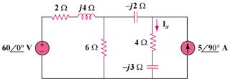

Figure 10.96
For Prob. 10.52.

